Experiment – 10
Question:
Create a Cloning of a VM and Test it by loading the Previous Version/Cloned VM using virtual box.
Answer:
AIM: To clone a virtual machine.
SOFTWARE REQUIRED: Virtual Box, Host OS: Windows
PROCEDURE:
STEP 1: Open VirtualBox
Click Start → Oracle VM VirtualBox
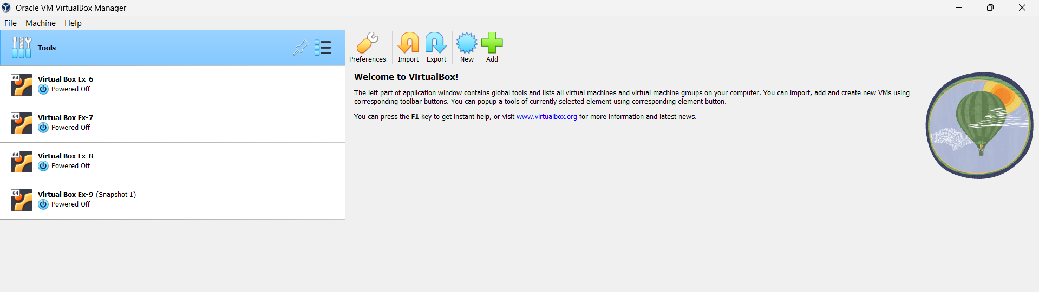

STEP 2: Create New VM
Click New
Name: Virtual Box Ex-10
Type: Linux
Version: Ubuntu (64-bit)
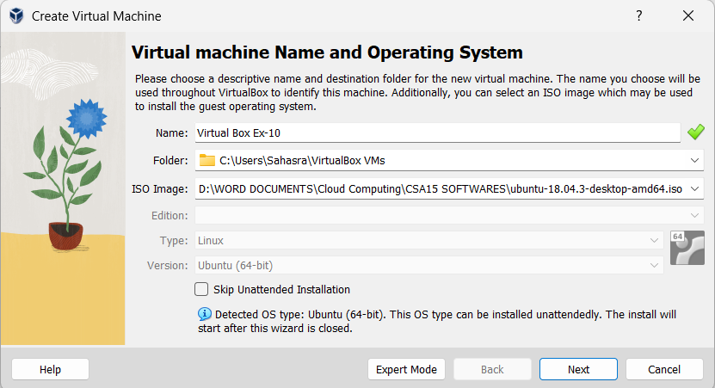
STEP 3: Select ISO File
Click ISO Image
Browse and select Ubuntu ISO
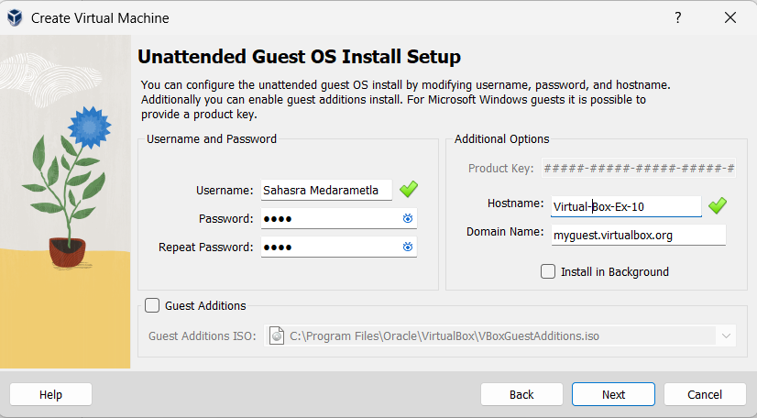
STEP 4: Set CPU = 1
Set Memory = 2048 MB
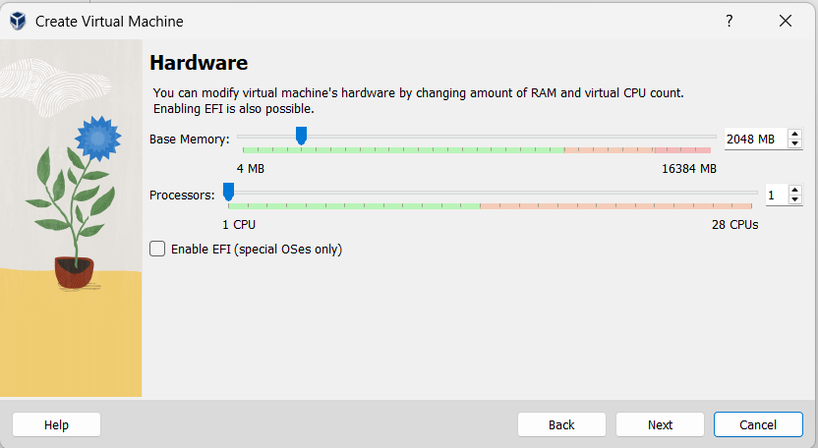
STEP 5: Set Disk Size
Verify disk = 25 GB
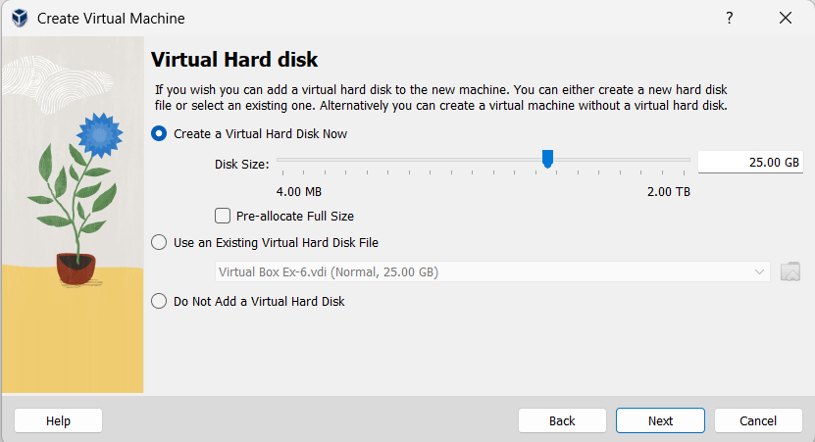

STEP 4: Finish Setup
Click Next → Finish
Click Start to run VM
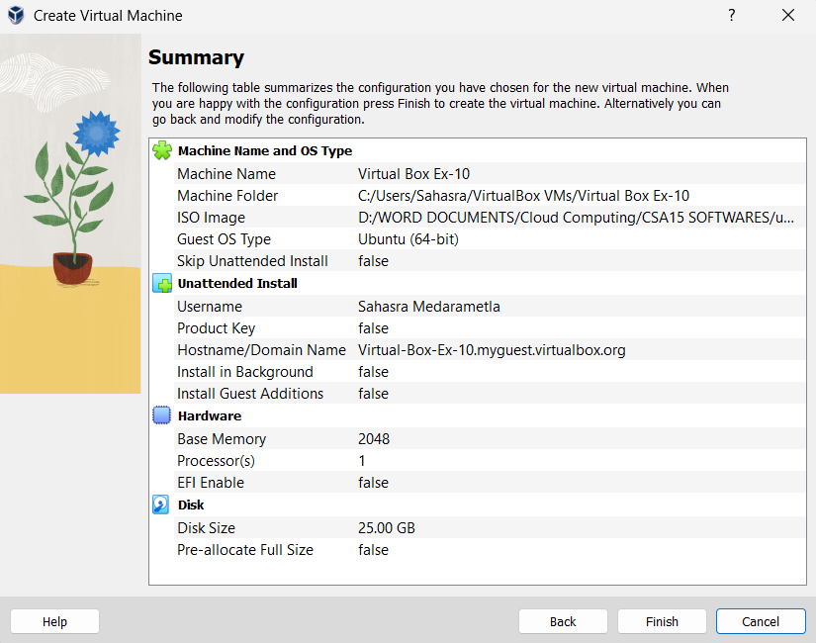
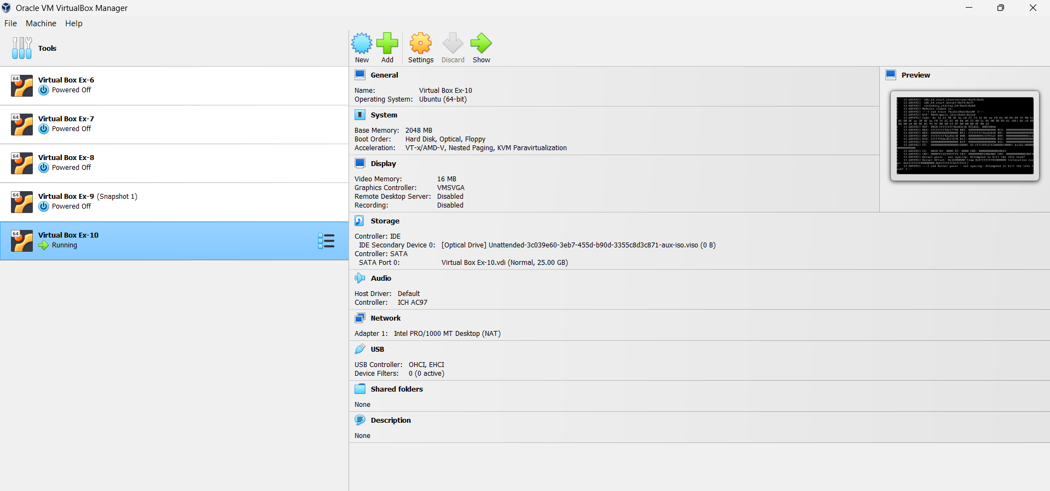
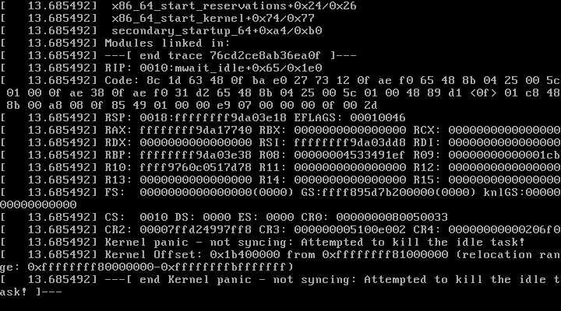
STEP 5: Power OFF VM
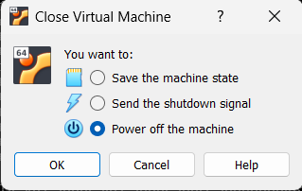
STEP 6: Clone
Right-click VM → Clone
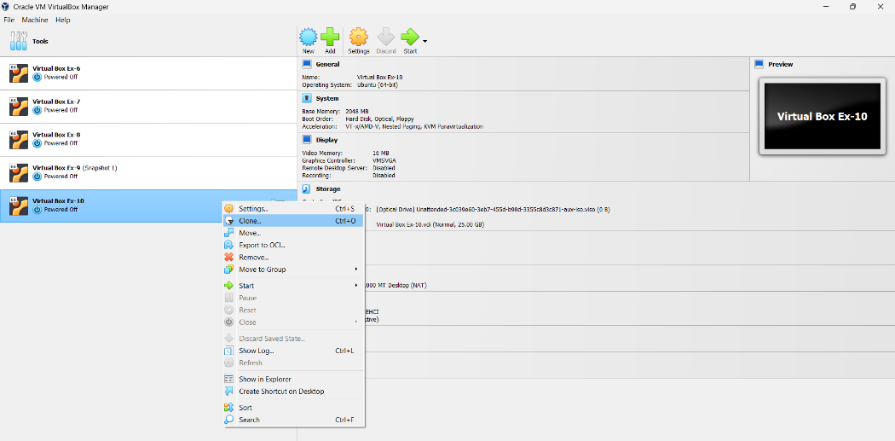

STEP 7: Name Clone
Name: Virtual Box Ex-10 Clone
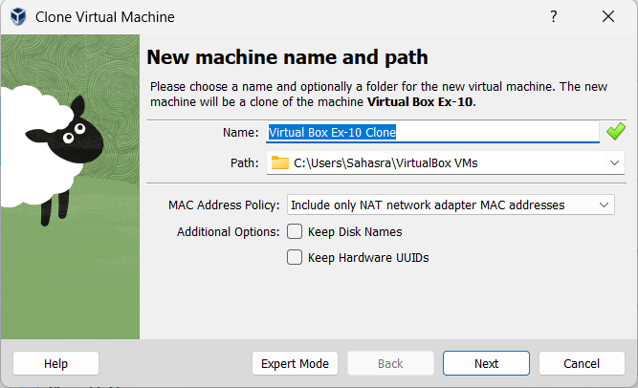

STEP 8: Clone Type
Choose Full Clone
Click Finish
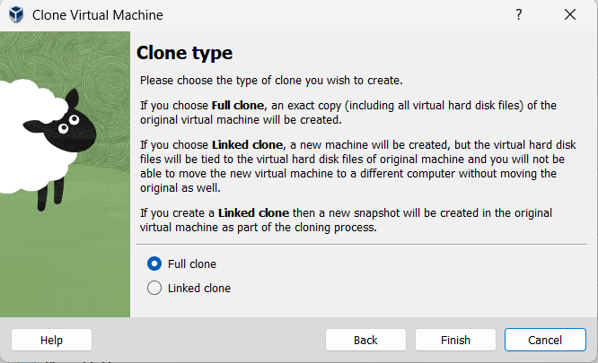
STEP 9: Test Clone
Start cloned VM
RESULT: VM cloning completed successfully.

